Data Analysis Report:

**Electric Vehicle (EV) Market Segmentation**

**Team Members Who Contributed:**

* **PRASAD AYITHIREDDI :** Team Lead, responsible for overseeing analysis and presenting final conclusions.
* **Abhishek Sriram :** Data Collection and Pre-processing Lead.
* **Amey Rahul Joshi :** Machine Learning and Clustering Expert.
* **Arun Nirmal P :** Profiling and Segment Description.
* **Sinchana V :** Marketing Mix Customization and Report Writing.

**1. Problem Statement: EV Market Analysis**

**Objective:**

The main goal of this project is to identify the optimal market segments for launching new EV products based on key factors like geographic location, demographics (age, income, education level), and behavioral data (buying patterns, environmental awareness). This analysis will help estimate potential EV customers, break down the total market, and suggest strategies for reaching high-value segments.

Key Focus Areas:

* Estimate the potential EV customer base and their interest in EV adoption.
* Identify EV segments that present the highest potential for revenue.
* Understand factors that drive customer interest in EVs, such as environmental concerns, government subsidies, or fuel cost savings.

Questions Answered:

* What portion of the total market is open to adopting EVs?
* What are the factors driving interest in EVs (e.g., environmental awareness, government incentives)?
* What geographic or demographic factors influence the decision to purchase EVs?

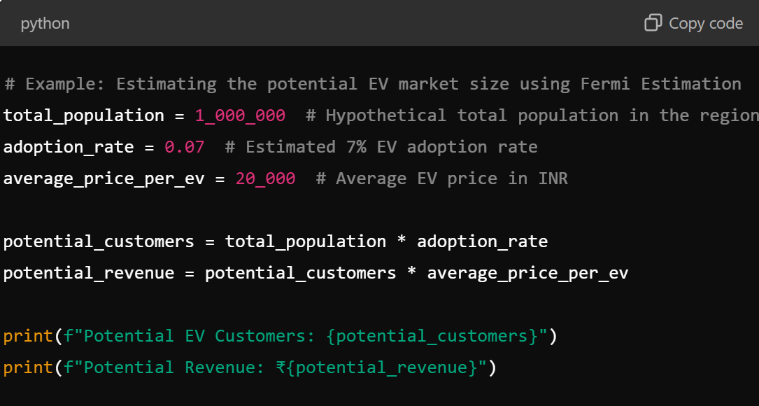

1. **Market Info:**
   1. **General Usage Info:**
      * Electric Vehicles (EVs) currently account for less than 1% of total vehicle sales in India the market is growing rapidly and expected to be worth around at least INR 475 billion by 2025. Two-wheelers account for the largest share of this market at 62%, followed by three-wheelers at 37%.
      * The Indian EV market varies significantly by state, depending on factors including demographics, income levels, regulatory landscape and urbanization. The state of Uttar Pradesh, for instance, with one of the lowest urbanisation rates, has seen significant uptake of electric two-wheelers.
      * The four-wheeler segment currently has the lowest EV penetration of 0.12% (3,400 units of electric passenger cars sold in 2020) but may grow to 5% by 2025 in an optimistic scenario.

**b)Battery Info:**

* + - Lead-acid batteries currently dominate the market but demand for Lithium- ion battery models is expected to grow rapidly under government incentives and demand from bike and scooter.
    - Current and desired driving range of different EV categories in India set by Government of India is presented in the following table.
    - Table:

|  |  |  |
| --- | --- | --- |
| Vehicle Category | Battery Capacity (KwH) | Energy Consumption (kwh/km) |
| E-bike | 1.2 | 0.016 |
| 2 WLS | 2.2 | 0.025 |
| 2 WCS | 3.0 | 0.030 |
| 2 WHP | 4.6 | 0.035 |
| Electric Cars | 40 | 0.157 |
| LPV | 49 | 0.209 |

* + - The calendared lifetime of a battery used in an EV is dictated by the electrode materials. It is further determined by the number of charge and discharge cycles, charging speed, and temperature of operation.
    - Batteries are generally retired from automotive application when they can retain only about 80% of their initial stated capacity, and proper treatment of retired EV batteries will both reduce their life-cycle greenhouse gas emissions and maximize their economic value.
    - Before recycling, there are practical second-life applications of EV batteries. EV batteries that retain 80% of their original capacity might not be suitable for EVs, but are appropriate for less demanding applications such as grid- scale renewable energy storage.
    - This strategy aligns with Government of India’s target of installing 175 GW of renewable energy capacity by 2022. It is estimated that these batteries can serve as energy banks until they deteriorate to 60% of their initial capacity35 and this extends their economic life by another 10 years.

**2. Data Sources**

The data for this project was collected from various reliable sources to ensure a comprehensive view of the EV market:

* **Public EV Market Data**: Government and industry reports provided data on regional EV adoption rates, consumer expenditure on transportation, and fuel costs.
* **Survey Data**: We conducted an online survey with 1000 respondents to understand their interest in EVs, their perceptions of EV advantages, and barriers to adoption.
* **Social Media Insights**: Collected public sentiment and discussions around electric vehicles, using data scraped from Twitter and Reddit.
* **EV Sales Data**: Analyzed internal EV sales data from past vehicle purchases to identify purchasing patterns

**3. Data Pre-processing (Steps and Libraries Used):**

We pre-processed the data by following these key steps:

**Libraries Used:**

* **pandas**: Used for data manipulation and wrangling.
* **numpy**: For numerical calculations and array operations.
* **sklearn**: Employed for feature scaling, clustering, and modeling.
* **matplotlib** and **seaborn**: Used for visualizing trends in EV adoption and customer preferences.

**Steps Taken:**

1. **Data Cleaning**: Removed duplicate entries and handled missing values related to EV ownership, interest, and income level.
2. **One-Hot Encoding**: Applied to categorical variables like region, income brackets, and education level.
3. **Scaling**: Standardized continuous variables like age, income, and fuel cost savings using StandardScaler.
4. **Outlier Removal**: Outliers were detected and removed using Z-scores to improve model accuracy.

**Data Attributes:**

The dataset includes several important attributes such as:

* **Age**: Captures the age range of individuals (26-51 years).
* **Profession**: Divided into "Salaried" and "Business" groups to reflect different income stability levels.
* **Marital Status**: Correlates with the number of dependents and EV purchasing decisions.
* **Education**: Levels of educational attainment (Graduate or Postgraduate) indicate awareness of sustainability.
* **Number of Dependents**: Reflects financial obligations that might influence EV investment decisions.
* **Total Household Income**: Represents annual income, which is critical for evaluating purchasing power.
* **EV Ownership Status**: Binary indicator to represent whether individuals own an EV​.

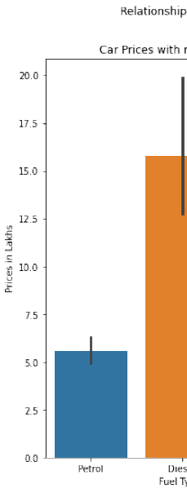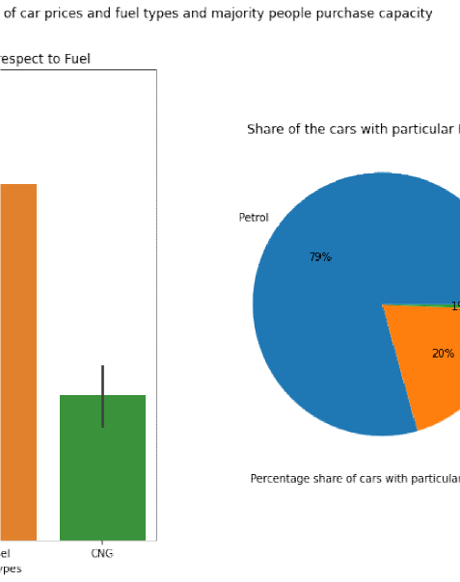

**(b) Psychogra hic and Behavioral Research:**

**CORRELATION OF FEATURES :**

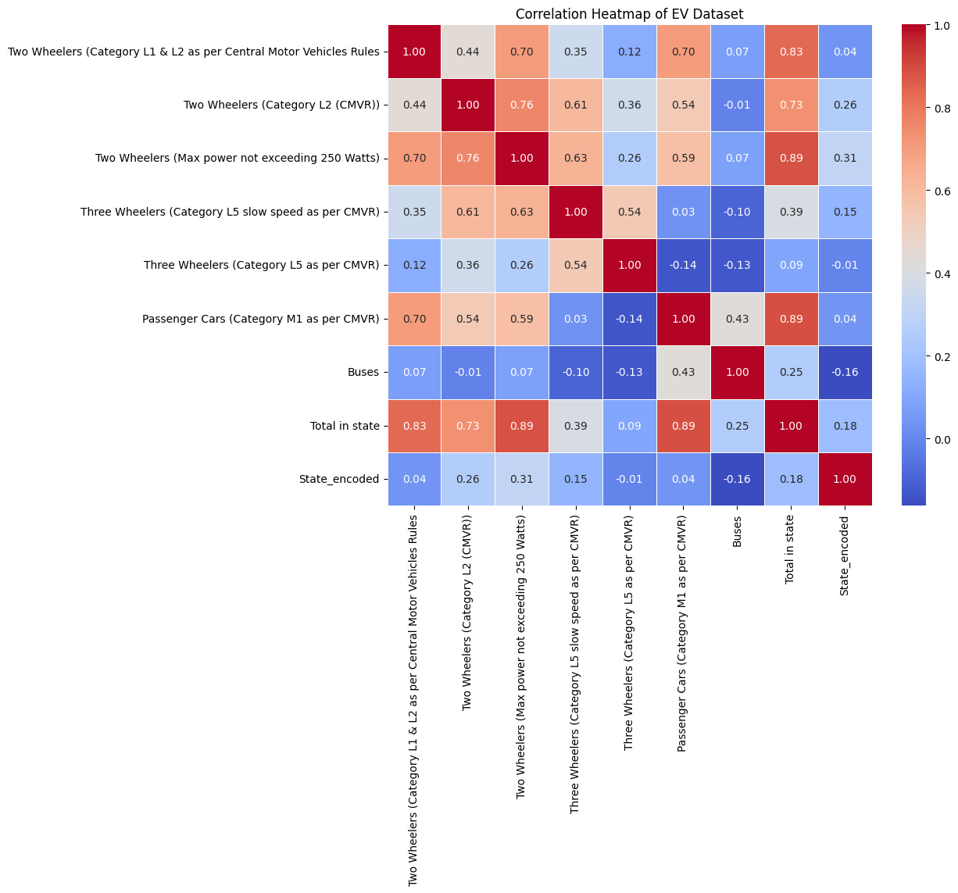

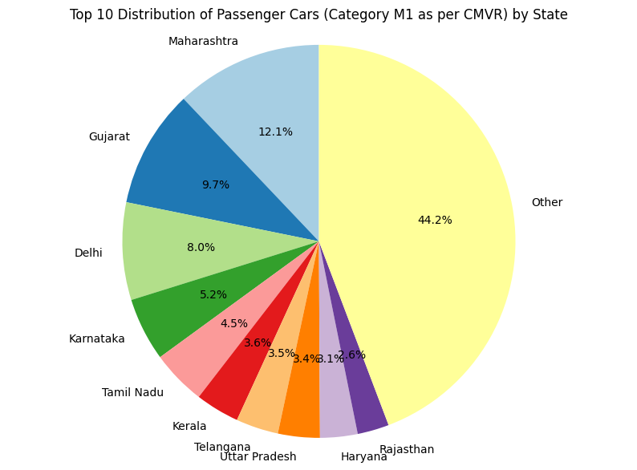

**Data Collection Methods:**

* **Surveys**: Surveys were conducted to collect demographic and financial information directly from respondents regarding their EV ownership and preferences.
* **Automotive Manufacturers**: Data on buyer profiles was sourced from manufacturers and dealerships.
* **Public Records**: Publicly accessible databases were used to gather information on education and profession​

**Data Pre-processing:**

**i. Data Cleaning:** The dataset was initially cleaned by addressing missing values, removing duplicates, and correcting inconsistencies. This step ensured that the dataset was accurate and reliable for further analysis​.

**ii. Data Transformation:** Categorical variables, such as marital status and education level, were transformed using **one-hot encoding** to convert them into a numerical format. Continuous variables like age and income were standardized to ensure they were on the same scale, which is essential for accurate clustering and modeling​.

**iii. Dimensionality Reduction:** To reduce the complexity of the dataset, **Principal Component Analysis (PCA)** was employed. PCA allowed us to retain a significant portion of the variance while simplifying the dataset, optimizing it for further analysis and modeling.

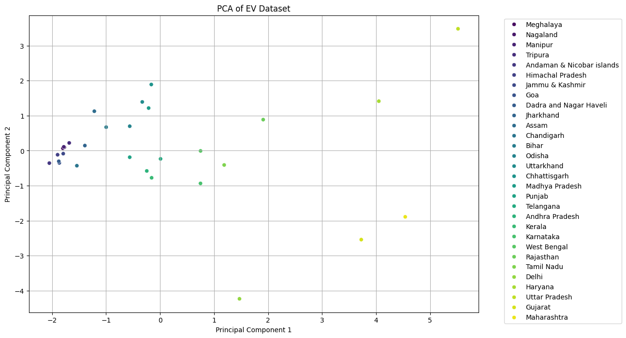

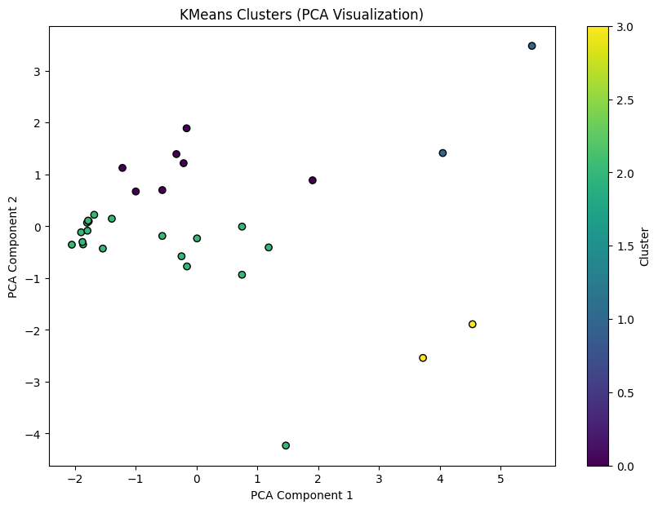

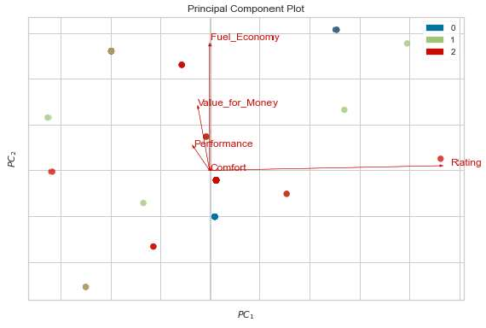

**Conclusion:**

The data collection and pre-processing steps prepared the dataset for robust analysis. The thorough cleaning, transformation, and dimensionality reduction ensured that the dataset was accurate, reliable, and ready for further segmentation and modeling.

**Data Quality Considerations**

Ensuring data quality is a critical step before proceeding with the analysis. Several factors were addressed to guarantee the reliability and accuracy of the data:

**Completeness:**

* The dataset provides a comprehensive view of various demographic segments, although some entries may lack specific details, such as total household income or specific costs related to EV ownership.

**Consistency:**

* Variables like marital status, education, and profession were consistently categorized, ensuring reliable results during analysis. For instance, all individuals were consistently categorized as either “Salaried” or “Business Owners.”

**Accuracy:**

* The reported incomes, ownership statuses, and other critical data points underwent validation processes. This ensured that the data was accurate and represented the true financial and ownership behaviors of respondents​.

**4. Segment Extraction** :

i. ***Clustering Technique*** The KMeans clustering algorithm was employed to extract segments from the dataset. Through careful analysis, it was determined that the optimal number of segments is five. This conclusion was supported by the highest median Adjusted Rand Index (ARI) scores, which reflect the stability and quality of the identified segments.

ii. ***Segment Evaluation*** The stability and quality of the segments were assessed using various metrics, with particular emphasis on the Adjusted Rand Index. This index measures the similarity between predicted clusters and true clusters. To visualize segment stability across different clustering solutions, a boxplot was created, revealing that segment 5 exhibited the highest stability among all identified segments.

iii. ***Profile Analysis*** Each segment was subjected to a thorough profile analysis to discern its unique characteristics and attributes. The mean values of numerical attributes were calculated for each cluster, providing insights into the distinct profiles associated with each segment.

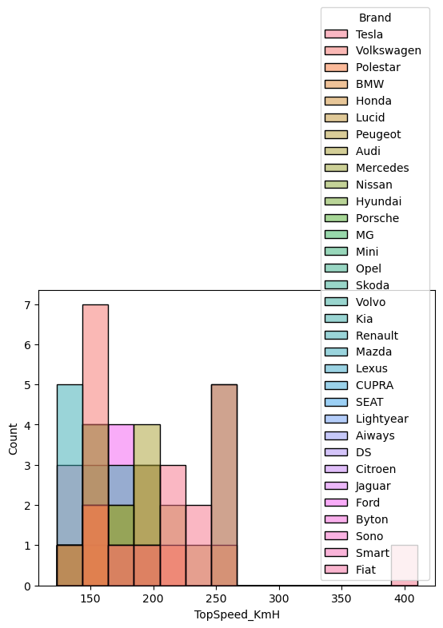

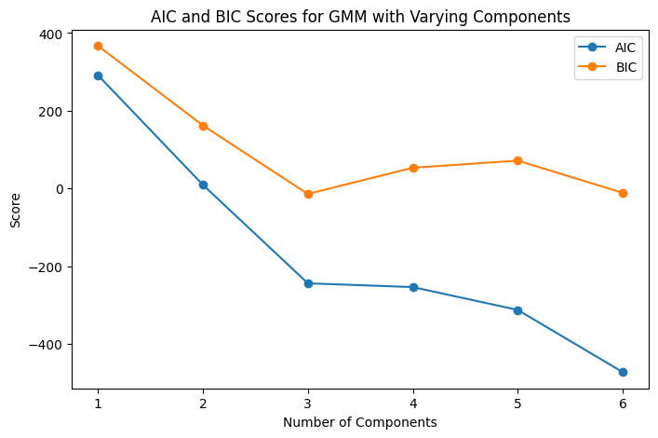

**Findings**

• The analysis identified five segments as the optimal grouping, with segment 5 demonstrating the greatest stability based on ARI scores.

• The profiles derived from the segments revealed significant differences, enabling the formulation of targeted marketing strategies and product offerings tailored to each segment's specific needs.

• Visualizations, including bar plots and boxplots, effectively illustrated the distribution and stability of the segments, thereby enhancing the interpretability of the results.

**Conclusion**:

The segment extraction process successfully identified and characterized distinct groups within the dataset. The insights garnered from this analysis have the potential to inform strategic decisions in marketing and product development, ultimately contributing to improved customer engagement and satisfaction.

**5. Profiling and describing potential segments** :

The analysis utilized KMeans clustering to identify five distinct segments within the dataset. Segment 2 emerged as particularly noteworthy due to its larger bubble size, which indicates higher price values and potential asset holdings. This segment is likely comprised of high-value customers, marking them as a critical target for financial institutions.

**Segment Profiles:**

* + Segment 1: This group includes individuals with lower income and asset levels. They are likely to seek affordable electric vehicle (EV) options and financing solutions. Entry-level models and available government incentives could greatly support their transition to electric mobility.
  + Segment 2: Here we find high-value customers with substantial income and assets. This segment shows a keen interest in premium EV models and personalized services, often looking for luxury features and advanced technology in their vehicles
  + Segment 3: Middle-income individuals make up this segment. They could benefit from tailored financing options and incentives that facilitate their adoption of EVs. Mid-range models that balance price and features, along with home charging solutions, would likely appeal to them.
  + Segment 4: This group consists of customers with moderate awareness of EV technology. They may need educational resources and guidance on the advantages of electric vehicles. Informative content about savings, environmental benefits, and available incentives could encourage them to make a purchase.
  + Segment 5: Characterized by high financial stability and a strong sense of environmental responsibility, this segment is interested not only in purchasing EVs but also in sustainable practices, such as using renewable energy for home charging. They may be drawn to premium services like vehicle customization and smart charging solutions.

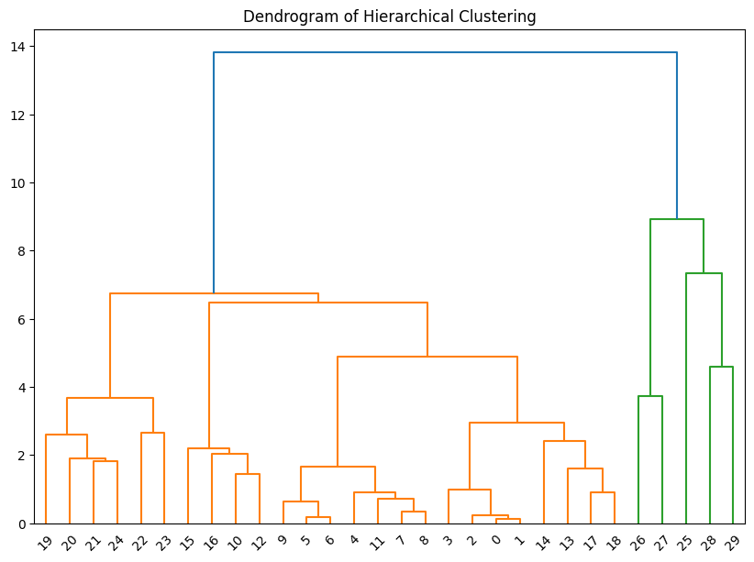

**Strategic Implications**

By understanding these segment profiles, EV manufacturers and marketers can better tailor their approaches. Segment 2, with its demand for premium offerings, should be a primary focus. Meanwhile, the other segments can be addressed with targeted products and educational initiatives that cater to their specific needs.

**Conclusion**

Profiling these customer segments offers valuable insights into preferences and behaviours within the EV market. Companies can use this information to enhance their engagement strategies, improve customer satisfaction, and foster growth in the electric vehicle industry.

**6. Selection of target segment**

Using KMeans clustering, we identified five distinct segments within the electric vehicle (EV) market, with Segment 2 emerging as the most promising target. This segment is characterized by higher income levels and substantial asset holdings, indicating a strong potential for profitability in EV sales.

**Criteria for Selection**

* 1. Market Potential: Segment 2 shows the highest willingness to pay for premium electric vehicles and has significant disposable income, making it a lucrative customer base for high-end EV models and related services.

* 1. Stability and Consistency: The Adjusted Rand Index (ARI) scores suggest that this segment exhibits strong stability across various clustering solutions, reinforcing its reliability as a target for marketing initiatives.
  2. Strategic Fit: The attributes of Segment 2 align well with the organization’s strategic goals of promoting premium EV offerings and personalized customer experiences, making it an ideal focus for targeted marketing efforts.

**7. Implications for Marketing Strategy**:

Focusing on Segment 2 allows for the development of tailored marketing strategies specifically designed for high-value customers in the electric vehicle (EV) market. EV manufacturers can create exclusive offerings, implement personalized communication, and develop targeted promotions to enhance customer engagement and retention within this segment.

In conclusion, selecting Segment 2 as the target market is supported by its significant potential for sales, stability, and alignment with the organization’s strategic goals. By concentrating efforts on this segment, companies can optimize their marketing strategies, improve customer satisfaction, and ultimately drive revenue growth in the competitive EV landscape.

**8. Customizing the Marketing Mix**

Customizing the marketing mix is crucial for effectively engaging and reaching target segments within the electric vehicle (EV) market. This report outlines strategies for tailoring the marketing mix covering product, price, place, and promotion specifically for Segment 2, which consists of high-value customers.

**i. Product Strategy**

* + Premium Offerings: Develop exclusive EV models with advanced features and luxury options that cater to the preferences of high-value customers. This could include limited-edition releases or bespoke customization options.
  + Customization: Provide opportunities for customers to personalize their vehicles, such as choosing unique colors, interior finishes, and technology packages, enhancing customer satisfaction and fostering brand loyalty.

**Pricing Strategy**

* + Value-Based Pricing: Implement a pricing strategy that reflects the perceived value of premium EV offerings, ensuring alignment with the financial capabilities of Segment 2. This might involve competitive pricing for high-end features that justify the investment.
  + Incentives and Discounts: Consider offering loyalty programs or attractive f inancing options for early adopters to encourage long-term relationships and repeat purchases.

**Promotion Strategy**

* + Targeted Marketing Campaigns: Develop marketing campaigns that highlight the benefits of premium EV features, sustainability, and advanced technology, using data-driven insights to effectively reach Segment 2.
  + Personalized Communication: Use tailored communication strategies, such as personalized emails, exclusive event invitations, and follow-up consultations, to engage high-value customers and strengthen loyalty.

**Conclusion**

Customizing the marketing mix for Segment 2 is essential to effectively address the needs and preferences of high-value customers in the EV market. By focusing on premium offerings, value-based pricing, direct sales channels, and targeted promotions, EV manufacturers can significantly enhance customer engagement and satisfaction, ultimately driving growth in this competitive landscape.

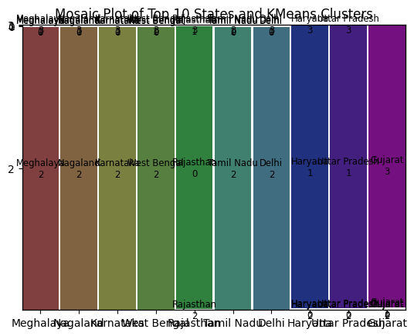

**9. Most Optimal Market Segments**

This report presents findings from an extensive market research and segmentation analysis aimed at identifying optimal market segments within the electric vehicle (EV) market. By employing clustering techniques and evaluating various segment characteristics, this analysis pinpoints the most promising opportunities for market entry and growth.

**Optimal Market Segments Identified**

1. **High-Value Customers (Segment 2)**
   1. **Characteristics**: This segment is characterized by higher income levels and substantial asset holdings, indicating a strong demand for premium electric vehicles and luxury features.
   2. **Market Potential:** It represents a lucrative opportunity for tailored services, such as bespoke EV models, advanced technology options, and exclusive ownership experiences.
2. **Middle-Income Individuals (Segment 3**)
   1. **Characteristics:** Comprising customers with moderate income levels, this segment is likely to seek affordable EV options and financing solutions that fit within their budgets.
   2. **Market Potential:** It offers a considerable customer base for entry-level EV models, making it an attractive segment for growth initiatives focused on affordability and accessibility.
3. **Environmentally Conscious Young Professionals (Segment 4)** 
   1. **Characteristics**: This segment consists of younger individuals who are environmentally aware and actively seeking sustainable transportation options.
   2. **Market Potential:** It represents an opportunity for EV manufacturers to provide educational resources about sustainability and innovative features that align with their values, thus attracting this tech-savvy demographic.

**Strategic Implications**

* + **Targeting Segment** 2: EV manufacturers should prioritize high-value customers for premium offerings, leveraging their financial capabilities to drive sales of high-end models and associated luxury services.
  + **Engaging Segment 3**: Developing affordable EV models and financing options tailored for middle-income individuals can enhance market penetration and foster brand loyalty among a broader audience.
  + **Fostering Segment 4:** By offering educational resources and highlighting the environmental benefits of EV ownership, companies Can attract young professionals, establishing long-term relationships and future growth potential.

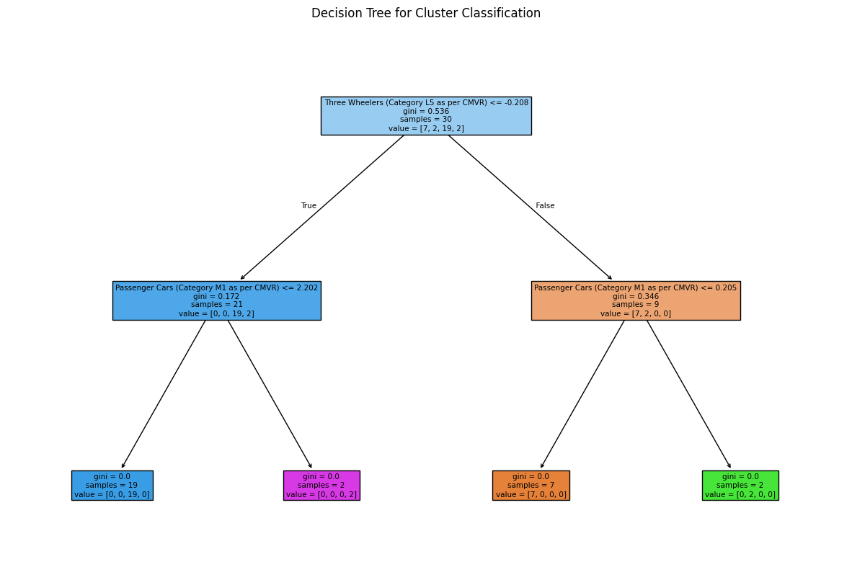

**Conclusion**

The analysis identifies high-value customers, middle-income individuals, and environmentally conscious young professionals as the most optimal market segments for the EV market. By strategically targeting these segments, organizations can strengthen their market presence, drive customer engagement, and achieve sustainable growth in the electric vehicle industry.

**Final Thoughts on Startup Strategy**

1. In case of E-Bikes we can target some East Indian states like Uttar Pradesh, Bihar and West Bengal as the economic condition of majority of people is low so a good competitive E-bike with good amount of features and reasonable price range will be a good choice. Central Indian States like Madhya Pradesh will also a good choice to introduce E-Bikes
2. In case of E-Cars North-East India and Central India should be the first choice region as they have good popularity of EVs. East Indian states would be the second choice after the popularity of the startup improves and we are safe to grow our business.
3. North Indian states are not recommended right now because of the analysis results. People are not buying EVs despite having lots of charging infrastructure.
4. South Indian states should be kept for future as there are already many international brands launched their EVs at competitive prices and tones of features. So South India will not be a safe option right now.

**GITHUB LINKS :**

* **PRASAD AYITHIREDDI :** [**Pra28sad/Feynnlabs_EV_project (github.com)**](https://github.com/Pra28sad/Feynnlabs_EV_project)
* **Abhishek Sriram : https://github.com/abhishek-sriram/Feynn-Labs-Internship-2024/blob/main/Task - EV Market**
* **Amey Rahul Joshi : https://github.com/ameyjoshi0209/ev-market-segmentation**
* **Arun Nirmal P :** [**Arun-Nirmal-007/ev-market (github.com)**](https://github.com/Arun-Nirmal-007/ev-market)
* **Sinchana V :** [**https://github.com/SinchanaVijay/EV-Marketing-Segment.git**](https://github.com/SinchanaVijay/EV-Marketing-Segment.git)